***Exercícios sobre datas e dimensões***

<https://learningapps.org/watch?v=pu4oc4ar521>

<https://learningapps.org/watch?v=p2s6yo4qk22>

**N°1 - Quais são as datas de nascimento e de falecimento dos artistas (ciade+país) ?** usar o pretérito :

Ela ***nasceu*** no dia ........em …… e ***faleceu*** no dia .....em …. **Tarsila do Amaral /Cândido Portinari / Bordalo II /Ana Vasconscelos/Belmiro de Almeida**

**N°2 – Escreve por extenso as dimensões dos quadros**

Ex : O quadro mede 25 por 37 centímetros

|  |
| --- |
| **Verbo MEDIR (irregular)** |
| Eu meço Tu medes Ele/ela/você mede Nós medimos Eles/elas/vocês medem |

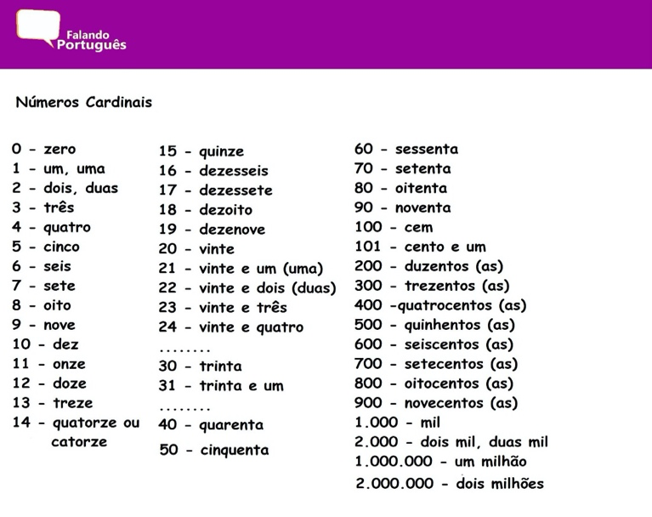

39 X 78 : ________________________________________________________

56 X 179 : ______________________________________________________  
  
______________________________________________________________

167 X 244 : ____________________________________________________

______________________________________________________________