Hoje é_____________________________________________________________________________

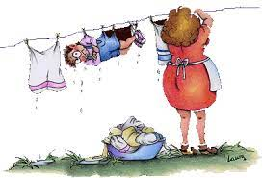

**Séance 2  :** Você concorda com os resultados?

***Écrire et réagir à l’écrit :*** *Rédiger en réaction à un sondage*

***Compétences****: Je suis capable de donner mon opinion sur les résultats d’un sondage*

1. 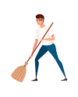Após ter realizado a sondagem sobre as tarefas domésticas que são mais realizadas pelos homens e mulheres, complete o gráfico abaixo com os resultados.

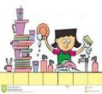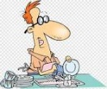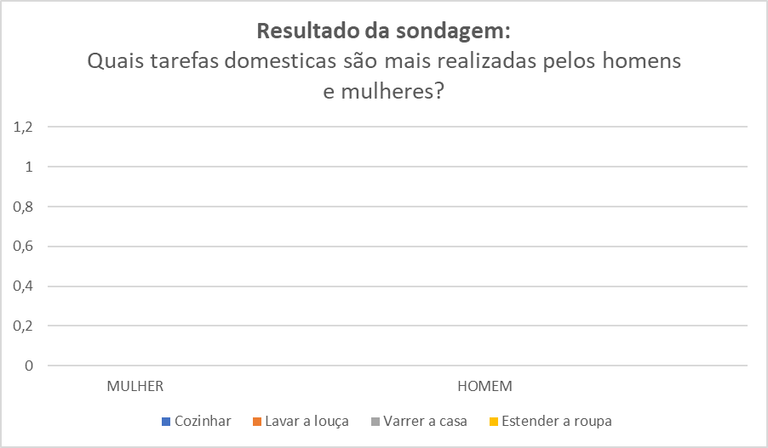

1. Agora escreva um curto parágrafo sobre os resultados. Depois dê a sua opinião, discordando ou concordando.

_________________________________________________________________________________________________________________________________________________________________________________________________________________________________________________________________________________________________________________________________________________________________________________________________________________________________________________________________________________________________________________________________________________________________________________________________________________________________________________________________________________________________________________________________________________________________________________________________________________________________________________

_______________________________________________________________________________

_______________________________________________________________________________

Cf **Document ci-dessous** : Na minha opinião… (Aide à la rédaction ou au débat)

