**VOCABULÁRIO DO CORPO HUMANO**

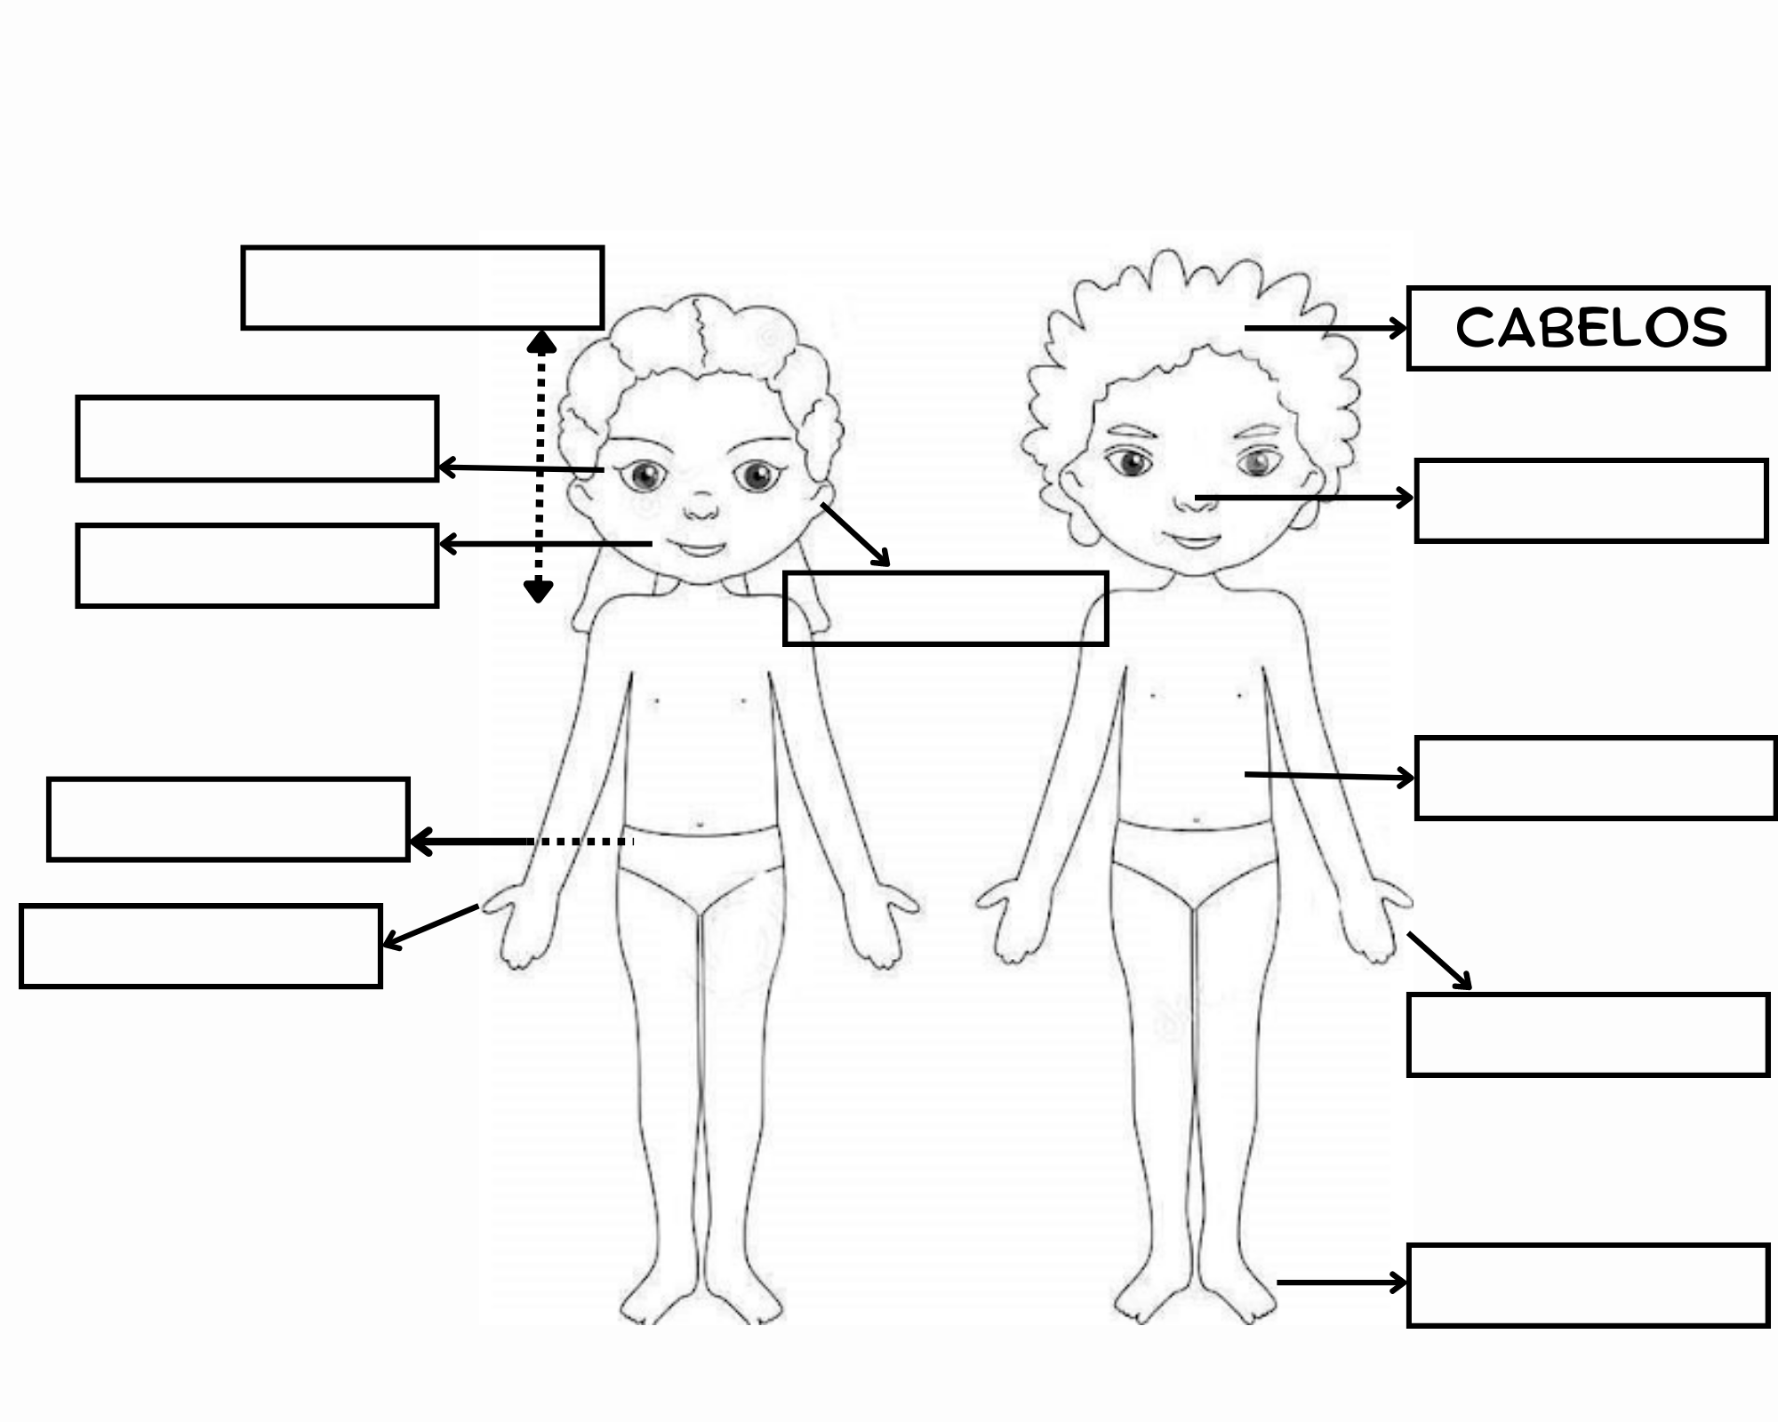

**---------------------------------------------------------------------------------------------------------------------------**

**___________________________________________________________________**

**EXERCÍCIO**

Traduz em português as frases seguintes.

a) J'ai deux pieds. ____________________________________

b) Tu as deux oreilles. ____________________________________

c) Il a de longs cheveux. ___________________________________

d) Nous avons des yeux verts. ____________________________________

e) Vous avez des sourcils fins. ____________________________________

f) Elles ont un visage rond. ____________________________________

**Vocabulário:**

sourcils: sobrancelhas

fin/e : fino/a

visage: rosto